**采集卡1技术参数**

1.最大输入： 1920x1200p@60/50fps in - 1920x1200p@60/50fps out

1920 x1080p@60/50fps in- 1920 x1080p@60/50fps out

2.几何尺寸：107x101.3( mm )

3.录制模式：软压缩，实时

4.主机接口：PCle x1（Gen1）

5.输入接口：1xHDMI，1xDVI-1，1xYPbPr，1xSD1，1xCVBS，1xS-Video

6.输出图像格式：YV12, NV12, YUY2,RGB24, RGB32

7.视频输入：

1920x1200p@60/50/30/25/24fps

1600x1200p@60/50fps

1920x1080p@60/50fps

1920x1080p@30/25/24fps

1920x1080i@60/50fps

1280x 720p@60/50fps

1280x 1024p@60fps

1280x 960p@60fps

1024x 768p@60fps

800x 600p@60fps

640x 480p@60fps

720x 480p@60fps

720x576p@50fps

720x 480i@60fps

720x576i@50fps

8.压缩模式：H.264( Software Compression )

9.分辨率：

1920x1200p@60/50/30/25/24fps

1600x1200p@60/50fps

1920x1080p@60/50fps

1920x1080p@30/25/24fps

1920x1080i@60/50fps

1280x 720p@60/50fps

1280x 1024p@60fps

1280x 960p@60fps

1024x768p@60fps

800x 600p@60fps

640x 480p@60fps

720x 480p@60fps

720x576p@50fps

720x 480i@60fps

720x576i@50fps

10.音频输入：1xSDl Embedded Audio,1xHDMl Embedded Audio, A Pair of RCA Audio Connector ( Audio L/R Through Component Cable )

11.音频格式：Stereo /16-bit/32000~48000Hz

12.WatchDog：支持

13.一机多卡：支持

14.SDK：Support APl :DirectShow, V4L2,FFmpeg, Gstreamer Support Language :C++,C#,NET, Visual Basic, Qt, Delphi

15.操作系统支持：Windows 7/ Windows 8 / Windows 8.1 / Windows 10 Linux 2.6.14 or Higher(32-bit and 64-bit )

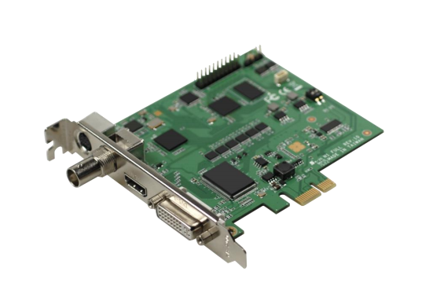16.提供多种规格适用不同尺寸机箱，多种规格接口搭配。

满分50分，每有一条一般参数不响应扣3.2分。